**Exercise for Introduction to HTML/CSS**

**1. How are inline and block elements different from each other?**

Ans: Inline Elements are used to align elements horizontally, or in other words, in the same line, WHILE, Block Elements don’t go in same line, each block element is in different line unless display:inline-block is used. Apart from that, we cannot set width and height properties for Inline Elements while same can be done for Block Elements.

**2. Explain the difference between visibility:hidden and display:none?**

Ans : An element with display:none is removed from the normal flow of page and there is no space allocated for it. They are accessible via DOMS.

An element with visibility:hidden means that that element is still there on the page, it’s only not visible i.e space is allocated for such elements.

**3. Explain the clear and float properties.**

Ans : Float property is used for formatting of contents in an element i.e their positioning either left or right. If float property is set to left/right for a content, then the content will go to leftmost/rightmost side of parent container.

Clear property in casual terms, avoids overlapping of containers when one of them is floated.

Clear property specifies what elements can float beside the cleared element and on which side.

For Example, if container1 is floated to left and then container2 is cleared to left, then container2 will go below container1 otherwise they might overlap.

**4. explain difference between absolute, relative,fixed and static.?**

Ans : Relative position means that the element will stay relative to its normal position and its position can be tweaked to move its left or right by specified pixels;

When an element’s position is set Absolute, it will become related to its nearest parent container.

Position of element with absolute property can be adjust inside parent container in top,bottom,left,right ways.

Element with Fixed property will be fixed on the page and will not move along the flow of page. In other words, we can scroll the webpage but element with fixed property will stay on screen;

Static: It’s default value of position of property.

**5. Write the HTML code to create a table in which there are 4 columns( ID , Employee Name, Designation, Department) and at least 6 rows. Also do some styling to it.**

Ans :

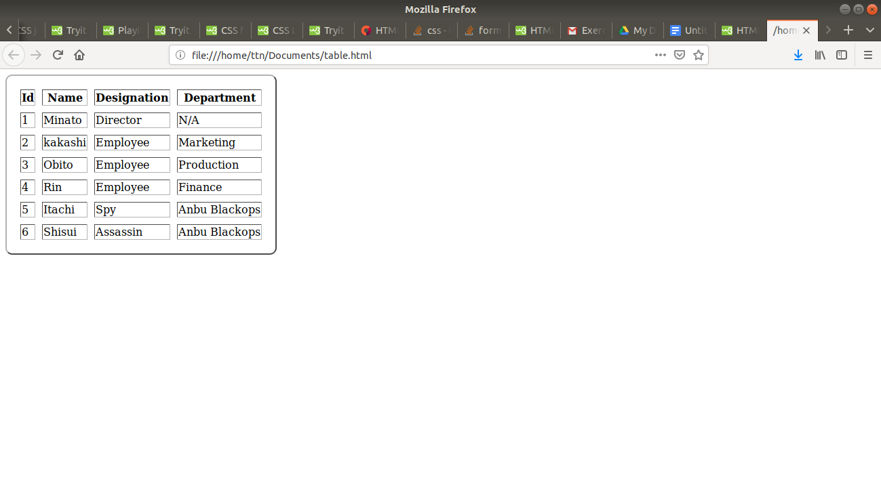

Table styled with cellpadding, cellspacing, outset border, border radius.

(Including a table.html file for reference to this Answer)

**6. Why do we use meta tags?**

Ans : The <meta> tag provides metadata about the HTML document. Meta elements are used to specify page description, keywords, author of the document, last modified, and other metadata. Also, it helps to improve the SEO( Search Engine Optimization) of a web page by using certain keywords related to the web page.

Such as :

<meta name="viewport" content="width=device-width, initial-scale=1.0"> will make a webpae responsive. width=device-width will set the page to devices width and initial scale will set initial zoom level.

<meta name="keywords" content="HTML, CSS, XML, XHTML, JavaScript"> will be used for Search engine optimization.

**7. Explain box model.**

Ans. The box model is essentially a box that wraps around every HTML element. It consists of: margins, borders, padding, and the actual content. The image below illustrates the box model:

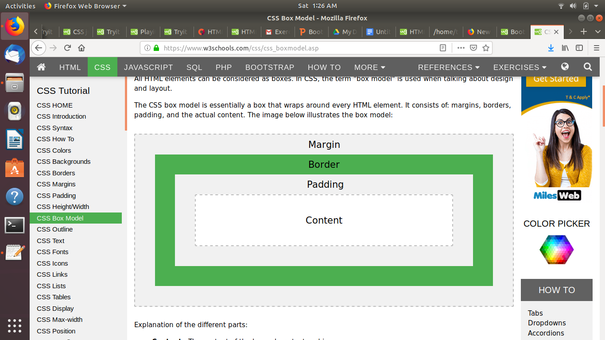

Where,

**Content** - The content of the box, where text and images appear

**Padding** - Clears an area around the content. The padding is transparent

**Border** - A border that goes around the padding and content

**Margin** - Clears an area outside the border. The margin is transparent

**8. What are the different types of CSS Selectors?**

Ans : Different types of css selectors are:

**“*”** : used to apply css to all elements of a webpage

“**Class**” : apply css to those elements that have a specific classname. Eg -

<p class=”style1”> </p>

.style1 { }

“**Id**” : apply css to those elements that have a specific id. Eg -

<p id=”para1”> </p>

#para1 { }

“**Element**” : apply css to all those specific element. Eg -

<p> </p>

p { } applies css to all p tags in a webpage

**9. Define Doctype.**

Ans : DOCTYPE is used to define document type of a webpage. It Identifies which html version is used. Without a doctype, documents get forced to render in quirk mode. The HTML syntax of HTML5 requires a DOCTYPE to be specified to ensure that the browser renders the page in standards mode.

If there is no doctype, or there's an unrecognized one, then it uses "quirks" mode and interprets the document as best it can. If there IS a doctype, and it recognizes it, then it follows the standards. The results of the rendering can vary depending on how it interprets the document.

**10. Explain 5 HTML5 semantic tags.**

Ans : Some semnati tags of HTML5 are:

<header> : defines header for a document. This tag typically contains Heading or Topic of content that follows later.

<footer> : defines footer for a document. This tag typically contains information about author of an article or a quote.

<nav> : used to make navigation bar for a webpage. Without <nav> links are placed inside unordered lists with display:inline property to make it seem similar to what <nav> does.

<section> : It divides pages into section. It is used to replace divs but work similar to them.

<article> : The <article> element specifies independent, self-contained content. It is used used in blogs and forums to make code more readable and easily understandable.

**11. Create HTML for web-page.jpg (check resources, highest weightage for answers)**

Ans : (uploading html file as web-page.html along with webpage.css)

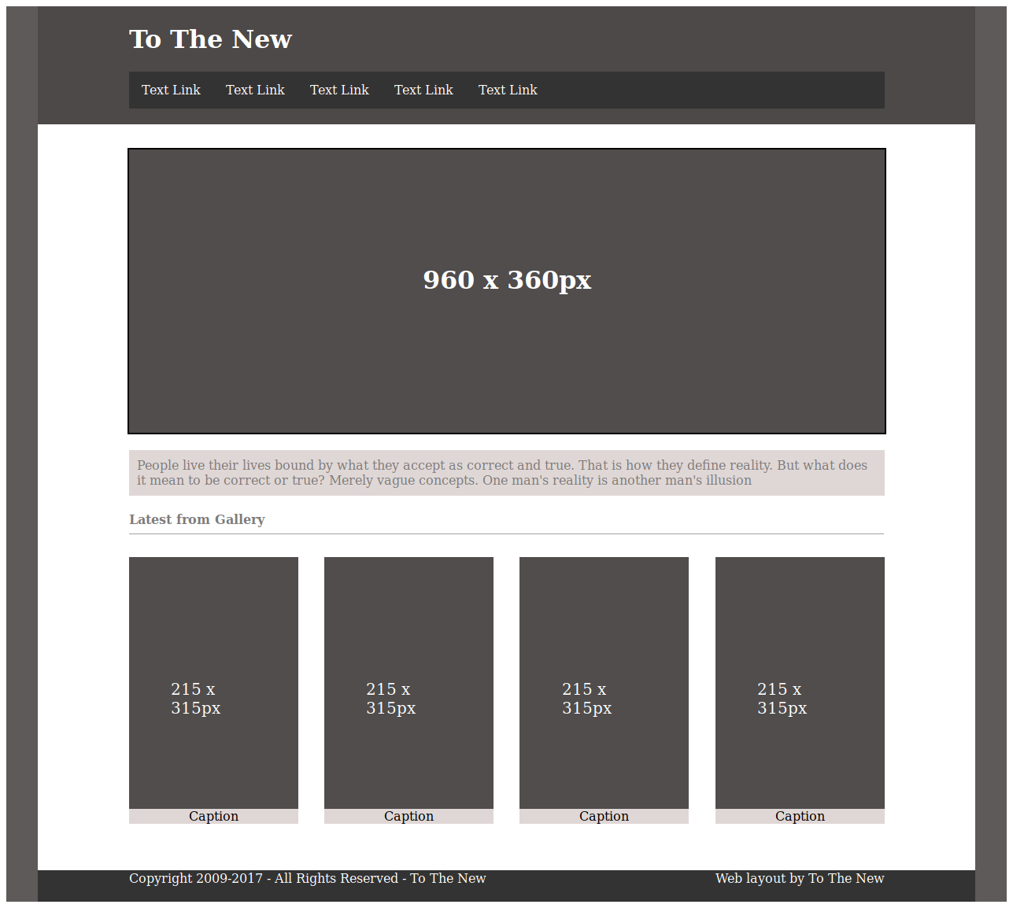

**12. Create HTML for form.png (check resources, highest weightage for answers)**

Ans : (Upload html file as form.html along with form.css)

